Software Engineering and Project

Software Design Document

PG5

Sai Dheeraj Reddy Pallavolu

Xuankai Feng

Junjie Zhao

Sharon Khate Damaso

Kalpana Parvathaneni

Ying Wang

Yuedong Wang

Lantian Cai

2.0

25/10/2019

Table of Contents

**Version History**3

**Introduction**3

Overview 3

Intended audience 3

References 3

Glossary 3

**Components Design**4

Component Decomposition Description 6

**Human Interface Design**8

Overview of the User Interface 9

Detailed Design of the User Interface 10

**Appendix A**15

# Version History

|  |  |  |  |
| --- | --- | --- | --- |
| Date | Version | Changer | Description |
| 29/09/2019 | 0.1 | Pallavolu Sai  Dheeraj Reddy | Finalized section introduction. Waiting for final document review |
| 30/09/2019 | 0.2 | Kalpana Parvathineni | Finalized the Component Design |
| 1/09/2019 | 0.3 | Pallavolu Sai Dheeraj Reddy | Finalized the Human Interface Design |
| 1/09/2019 | 0.4 | Pallavolu Sai Dheeraj Reddy | Merged three sections into smooth report, organized structure |
| 1/09/2019 | 0.5 | Kalpana Parvathineni | Modified and added the images |
| 2/09/2019 | 1.0 | Pallavolu Sai Dheeraj Reddy | Added flowcharts and Modified |
| 23/10/2019 | 1.1 | Pallavolu Sai Dheeraj Reddy | Modified the report base on the client feedback |
| 24/10/2019 | 1.1 | Pallavolu Sai Dheeraj Reddy | Added the figures and images |
| 25/10/2019 | 1.1 | Pallavolu Sai Dheeraj Reddy | Final version of SDD |
| 26/10/2019 | 1.2 | Sharon Khate Damaso | Updates the Overview of the User Interface |
| 26/10/2019 | 1.3 | Pallavolu Sai Dheeraj Reddy | Updated the Final version of SDD |

# Introduction

## Overview

This document primarily introduces the software design of the Hire Me Coder. The main purpose of this document is to deliver a comprehensive and detailed description of the software design of Hire Me Coder. It is expected to produce a baseline for software development as it elaborates the process of building the system and understand the software components are to be built. This document provides necessary information.

## Intended audience

This document can be read by all related stakeholders.

All the development team members are intended audiences. This Document can be viewed for all members to comply with design principle and follow the procedure. Moreover, both scope part and process part are helpful for developer to ensure all requirements can meet the expectation of client

Clients from MapTek are audiences of this report. Clients will be interested in all sections of this document they can understand our design document plan of Hire Me Coder.

## References

Software Project and Management Plan Draft

Software Project and Management Plan Final Documentation

Software Design Documents Draft

System Requirement Specification Draft

System Requirement Specification Final Documentation

The interview with clients of project specification

## Glossary

|  |  |
| --- | --- |
| **Agile Methodology** | A software development approach that promotes continues iteration of development and testing throughout the software development life cycle |
| **GitHub** | Software Development version control |
| **MapTek** | A leading provider of innovative software, hardware and services for the mining industry |
| **Scrum** | An agile process framework |
| **Slack** | Communication Tool |
| **SPMP** | Software Project Management Plan |
| **Trello** | Web-based list-making application |
| **QA** | Quality Assurance |

Components Design

## Component Decomposition Description

1. **Administration Registration:** The Administrator will register other MapTek staff using their email address and the staff will receive an email containing the temporary password to login to the system.

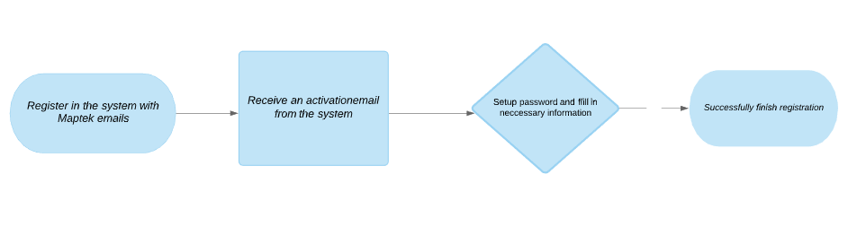

*Figure 1: Flow of Administration Registration*

1. **Administrators Login:** The Admin can login to the system with full rights.

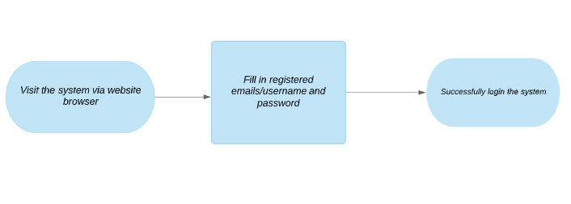

*Figure 2: Flow of Administrator Login*

1. 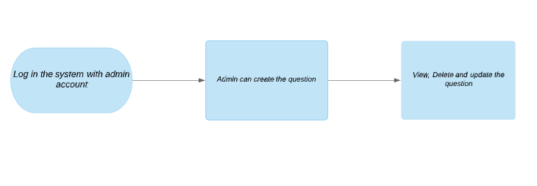**Manage Questions:** The Admin can create, view, update, and delete the question that will be included on the Test.

*Figure 3: Flow of Manage Questions*

1. **Manage Test:** The Admin can create a test and includes the questions, view, update, and delete it.

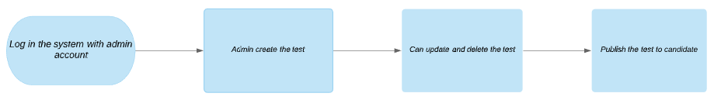

*Figure 4: Flow of Upload Test Cases*

1. **Assessment Invitation:** The Admin sends an email assessment invitation to the candidates.

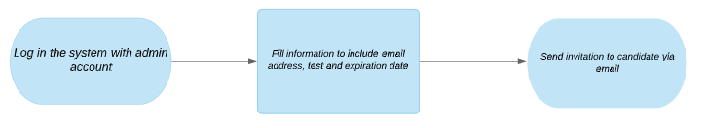

*Figure 5: Flow of Assessment Invitation*

1. **Manage Profile:** The Candidate and Admin can view and edit their profile details like First name, Last name and password.

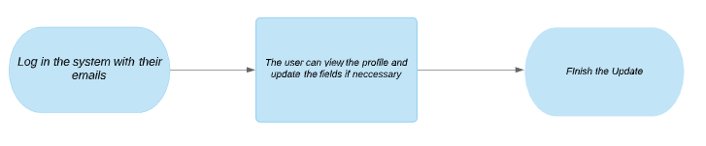

*Figure 6: Flow of Manage Profile*

1. **Take the Test:** Once the candidate receives an email from MapTek, the candidate can login to the system and start the test. The candidate also has an option to save the test as draft and submit it before the deadline. Finally, the candidate can submit the test once all questions have been answered.

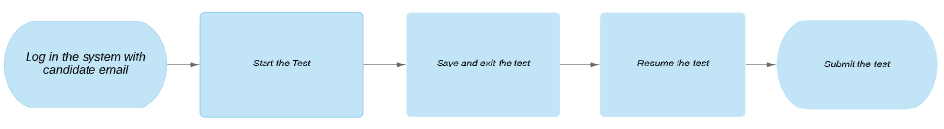

*Figure 7: Flow of Acquire Testing Case*

**Use case diagram:**

To be specific to our Use case, we create use case diagrams to help users to understand the functionalities and how the application behaves. The below diagrams show simplest representation of a user’s interaction with the system that shows the relationship between the user and the different use cases in which the user is involved. This show the dependent of each other of the function between the Admin and Candidate.

|  |  |
| --- | --- |
| *Figure 8: Admin - Use Case Diagram* | *Figure 9: Admin - Use Case Diagram* |

## 

## **Class Diagram**

Class diagram is a type of static structure diagram that describes the structure of the system by showing the systems classes, attributes, operations and the relationships among objects. The classes in a class diagram represent both the main elements, interactions in the application, and the classes to be programmed. The diagram which represent that each system where the functionality of the flow. The flow can be seen clearly below figure.

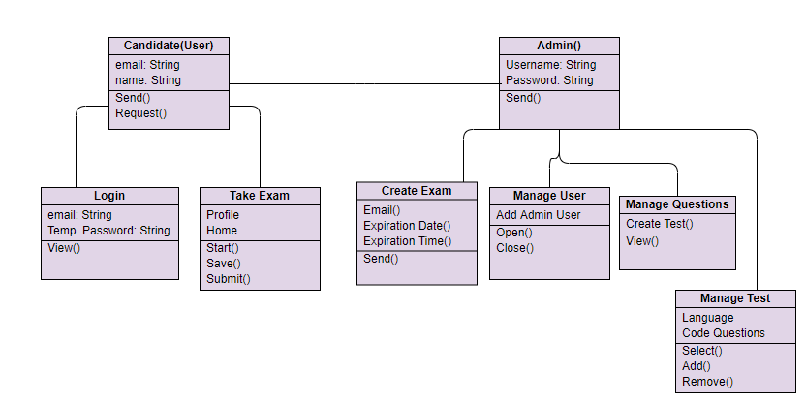

*Figure 10: Hire Me Coder Class Diagram*

**State Diagram**

A state diagram describes the behaviour of systems. State diagram require that the system described is composed of a finite number of states. It is also known as a state machine diagram or state chart diagram, is an illustration of the states an object can attain as well as the transitions between those states in the Unified Modelling Language (UML).The state diagram is the main operation of the Hire-me Coder that can see the flow of the functionality.

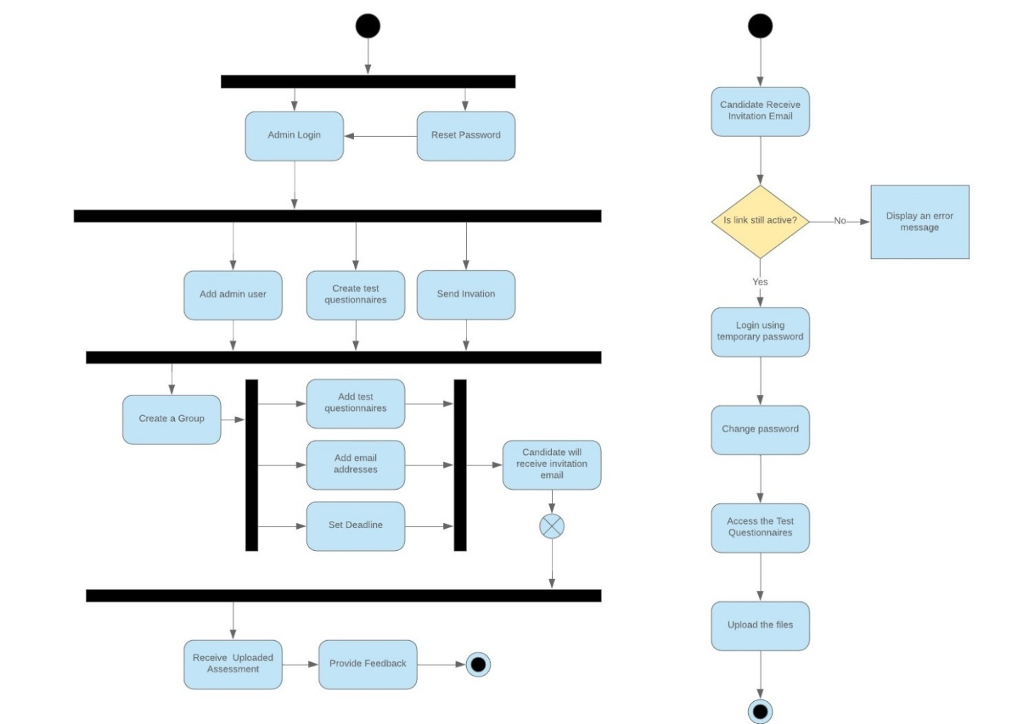

*Figure 11: Hire Me Coder State Diagram*

# 

# Human Interface Design

## Overview of the User Interface

**Functionalities:**

1. Login – The Admin and Candidate can login to the MapTek – Hire Me Coder system. Both roles have different access rights.
2. Admin Functionalities:
   1. Manage Admin User – The admin manages the admin users wherein the admin can create a new admin account, view admin profile details, and activate/deactivate the admin account.
   2. Manage Question
      1. View Question – Initially, the Manage Question Page displays the list of the questions including *code* and *descriptive* questions.
      2. Create Question - The admin creates the question that will be added in test creation. The system also records who created the question.
      3. Update Question – The admin can update the question details and will be saved to the database including who updated the question.
      4. Delete Question – The admin can delete an existing question.
   3. Manage Test
      1. View Test – Initially, the Manage Test Page displays the list of the tests.
      2. Create Test – Upon clicking the *Create Test* button, it will pop up the create test page and populate the questions that can be added upon creating the test. The admin needs to specify the test name as well as the test description.
      3. Update Test – The admin can update the test content such as: update the description and add/delete the question.
      4. Delete Test – The admin can delete an existing test.
   4. Send Assessment – Once the test is created, the admin can send an assessment invitation to the candidates by specifying their email addresses, selecting the test, and defining the expiration date. Once done, the system will send an email to the candidate that includes the login link, username, and temporary password.
3. Candidate
   1. Receive Email – The candidate will receive an email assessment invitation from the MapTek, and the email contains their credentials in order to login to the system.
   2. Take the Test – Once logged on, the candidate can begin the test as long as the deadline of the test is still valid. Otherwise, the candidate has no access to the expired test.
   3. Save the Test – The candidate has an option to save the test without submitting it yet.
   4. Resume the Test – The candidate can resume an unfinished test within the deadline. Otherwise, all saved test will automatically send to the MapTek Admin.
   5. Submit the Test – The candidate can submit the test after all the questions have been answered. Once submitted, the candidate can no longer access the test.
4. Manage Profile – The admin and candidate can view their profile and update the details if necessary.
5. Change Password – The admin and candidate can change their passwords.
6. Reset Password – If the users forgotten their passwords, the users have the capability to reset their password. They will receive an email password reset.

## 6.2 Detailed Design of the User Interface

**6.2.1 Login**

The user interactive interface includes market-hire me coder login page which contain email id, password at last there is a sign in button.

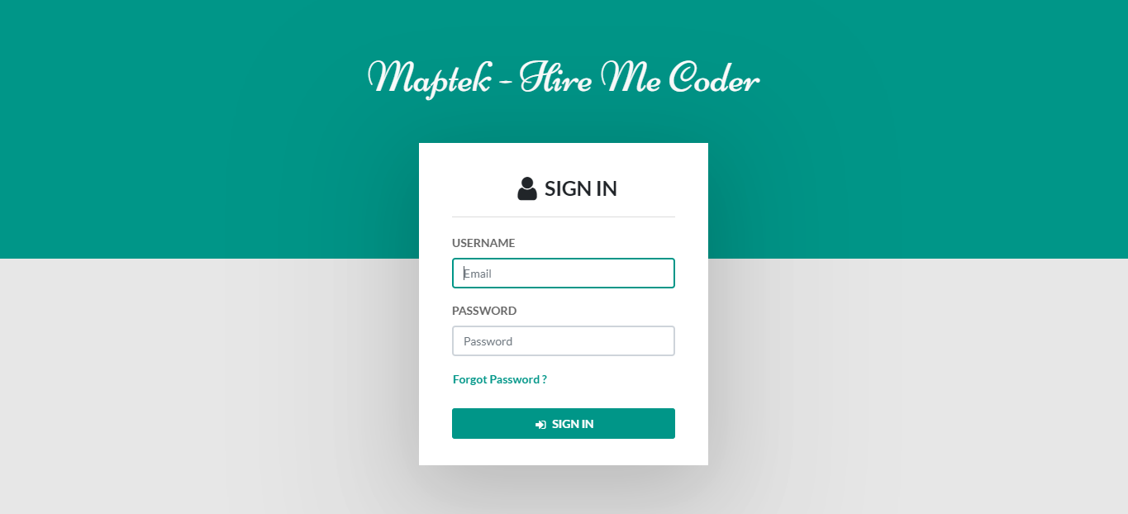

*Figure 12: Main Screen of UI*

**6.2.2 Home page**

This page displays the home page of Admin of the hire me coder system on which displays the side navigation bar such as Manage Users, Manage Questions, Manage Tests, and Send Assessment.

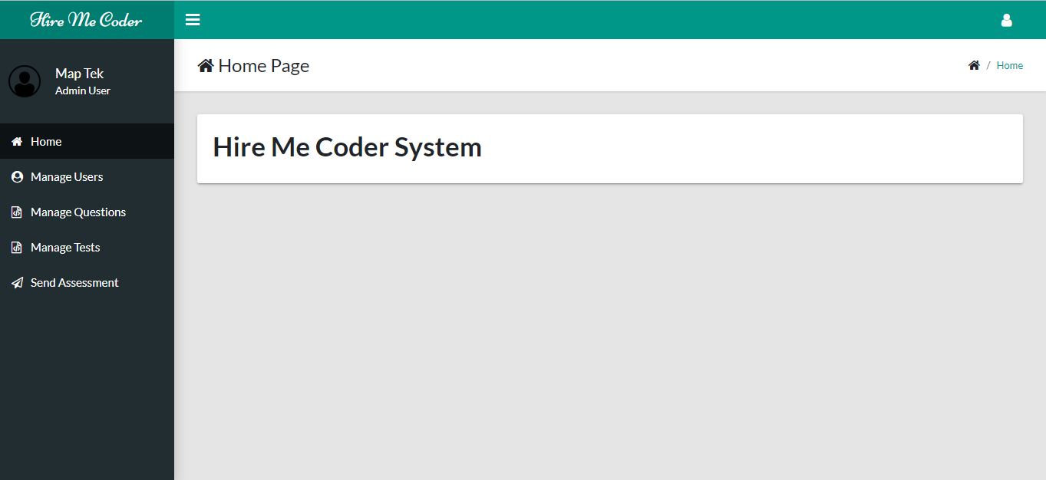

Figure 13: Admin Home Page

**6.2.3 Manage user**

This part of the interface displays the manage user interface provides information regarding adding the new admin therefore admin is the one who can edit and deactivate the account.

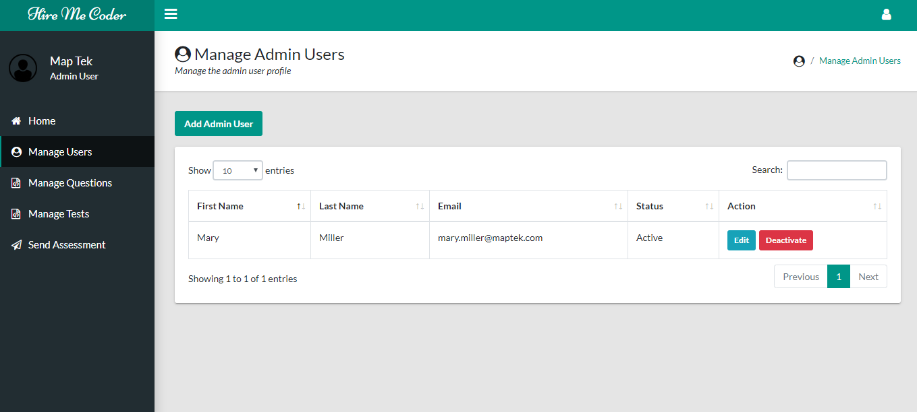

*Figure 14: Manage User Page*

**6.2.4 Manage Questions**

This part of the interface displays the questions to be selected to the test creation. The admin can view, update, an delete the question under *Action* column.

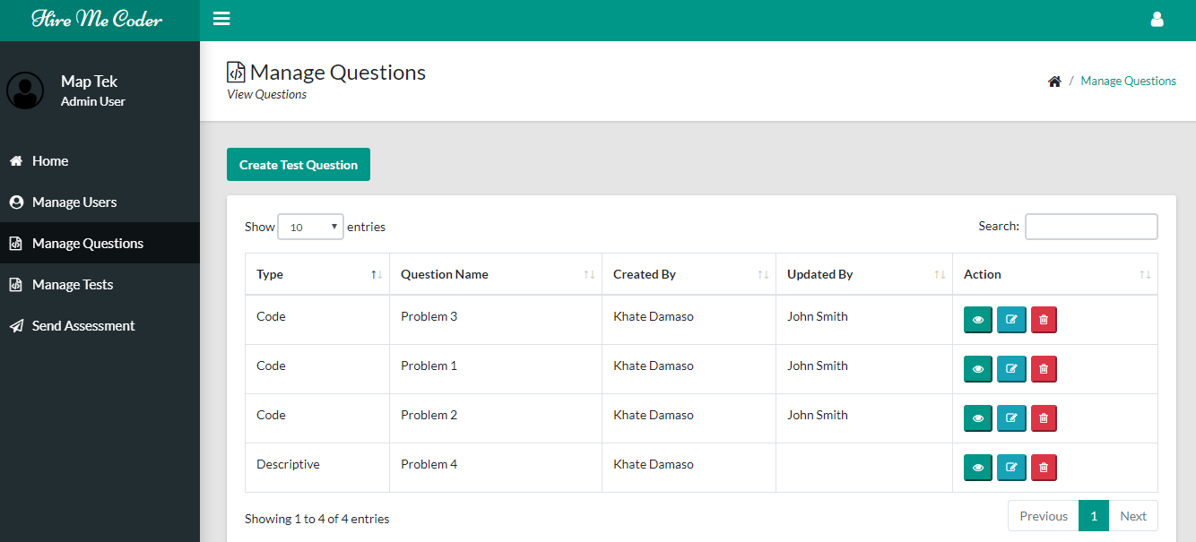

*Figure 15: Manage Questions Page*

**6.2.5 Manage Test**

The admin can manage the test by creating the test, update the test and delete the test.

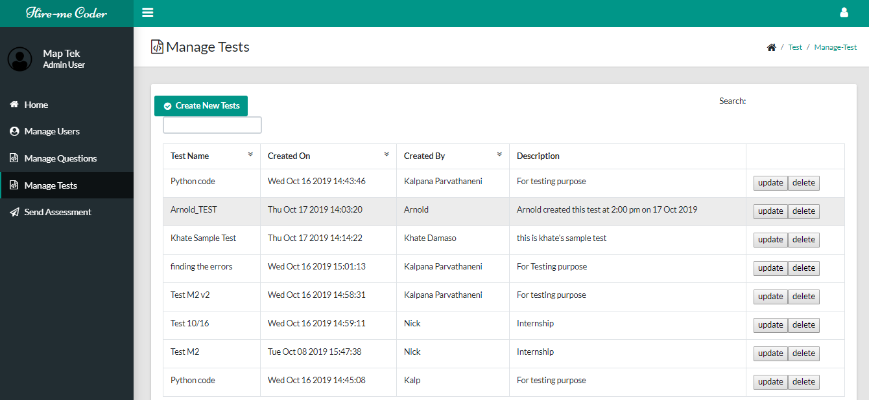

*Figure 16: Manage Test Page*

**6.2.6 Send Assessment**

The admin can send an assessment invitation to the candidates.

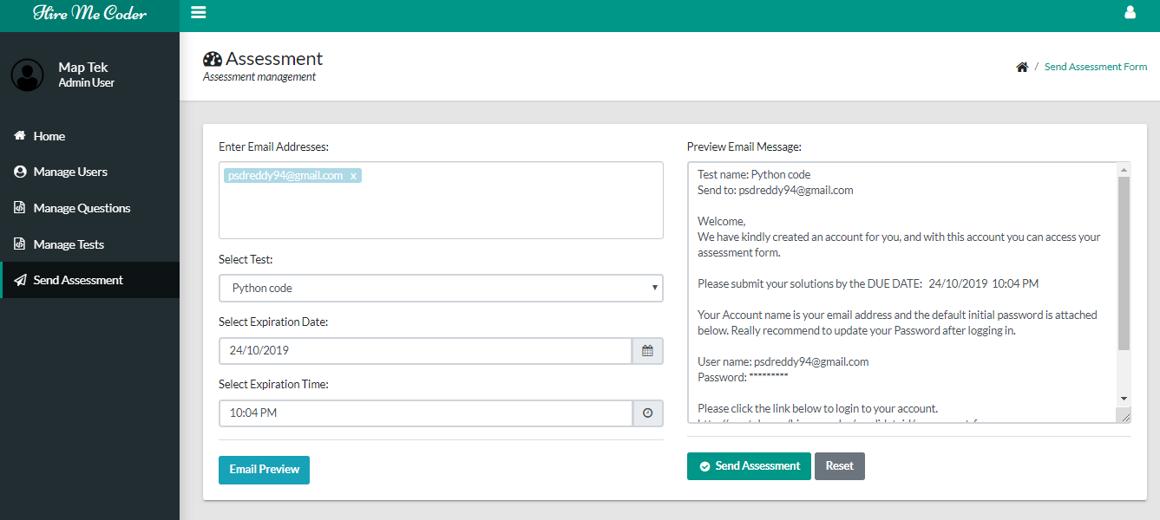

*Figure 17: Send Assessment Page*

**6.2.7 Candidate Homepage:**

This is the Candidate Homepage after the candidate is logged in using their correct credentials. The Homepage displays the test information.

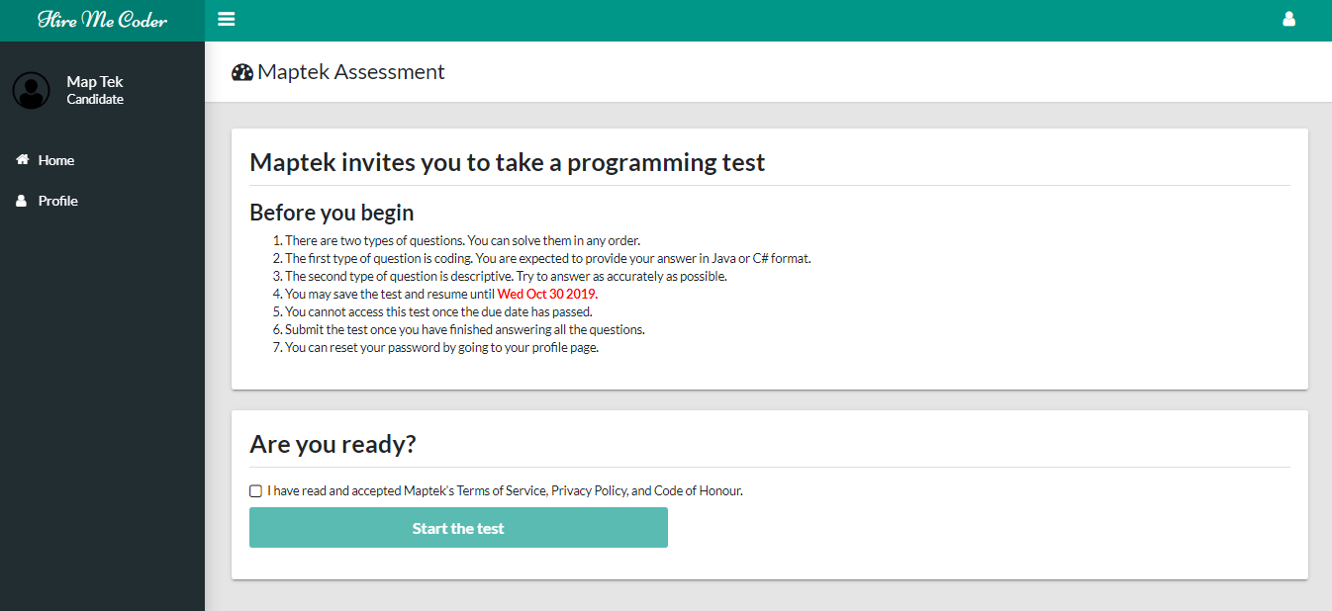

*Figure 18: Candidate Homepage*

**6.2.8 Test page:**

The system will redirect the candidate once the test has been started. The candidate has an option to save the test then resume it later; or submit the test once all the questions have been answered.

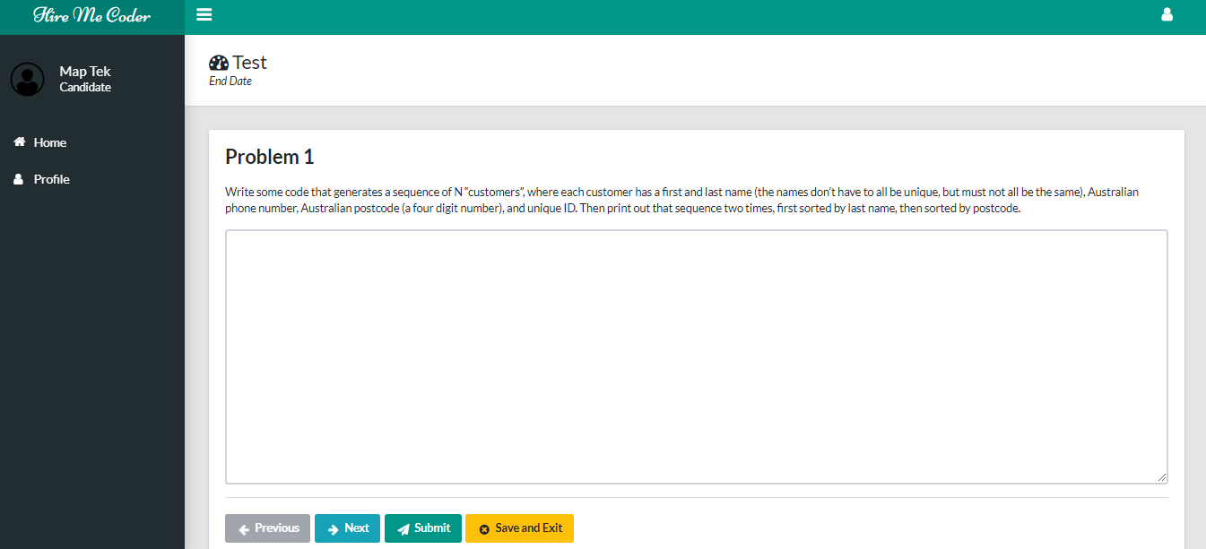

*Figure 19: Test Page*

**6.2.9 Resume Test Page:**

The Candidate can save and exit the test and can resume the test whenever candidate feel to do the test.

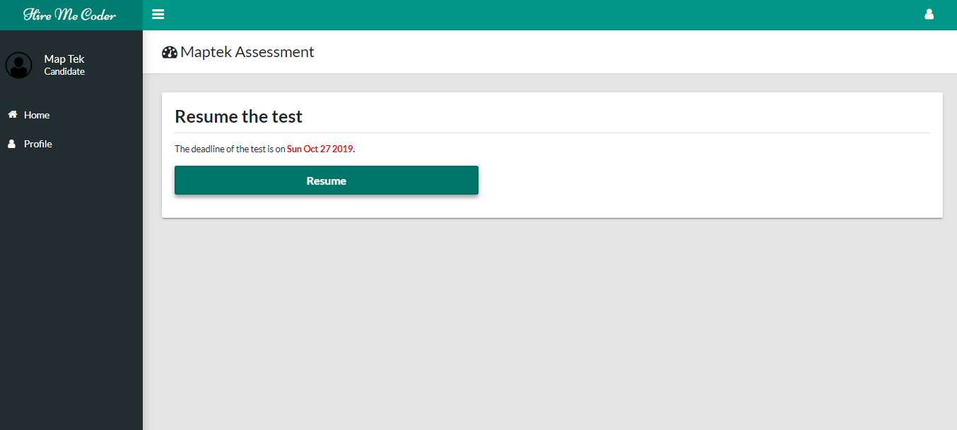

*Figure 20: Resume Page*

**6.2.10 Expired Test Page:**

If the candidate does not login within the expiration time, then the test is denied.

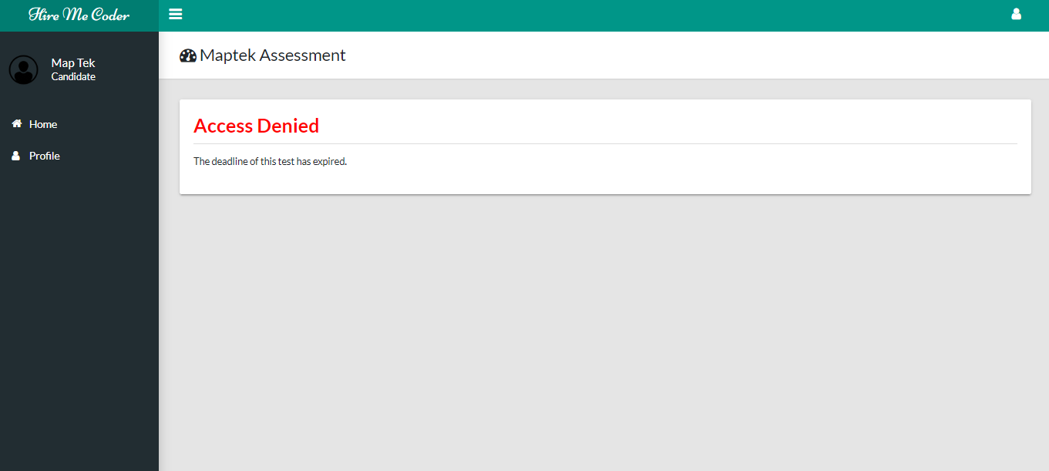

*Figure 21: Expiration Page*

# Appendix A

Figure 1: Flow of Administration Registration

Figure 2: Flow of Administrator Login

Figure 3: Flow of Manage Questions

Figure 4: Flow of Upload Test Cases

Figure 5: Flow of Assessment Invitation

Figure 6: Flow of Manage Profile

Figure 7: Flow of Acquire Testing Case

Figure 8: Admin - Use Case Diagram

Figure 9: Admin - Use Case Diagram

Figure 10: Hire Me Coder Class Diagram

Figure 11: Hire Me Coder State Diagram

Figure 12: Main Screen of UI

Figure 13: Admin Home Page

Figure 14: Manage User Page

Figure 15: Manage Questions Page

Figure 16: Manage Test Page

Figure 17: Send Assessment Page

Figure 18: Candidate Homepage

Figure 19: Test Page

Figure 20: Resume Page

Figure 21: Expiration Page